## Artificial Dataset

The un-mixing matrix plot can be found below. The variance of the two components is 1.

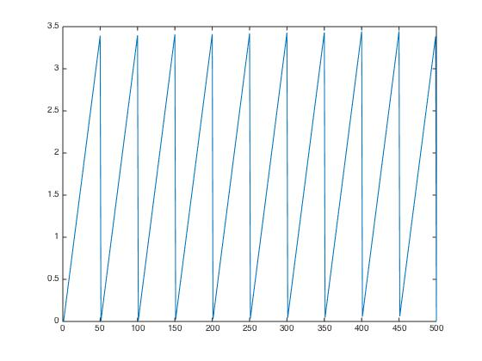

Figure : unmixing Matrix, component 1

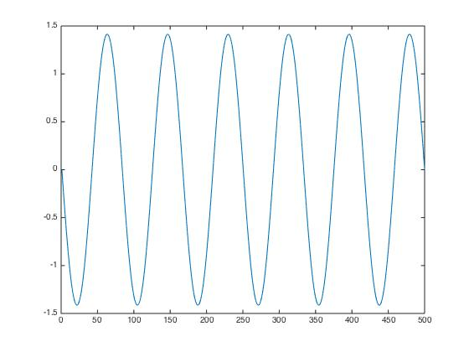

Figure : unmixing matrix, component 2

## Audio1/2/3

When testing raw audio1, I feel that channel 1 has stronger bass than channel 2, and both channels have non-biased guitar, bass, and drum cords (coming from both speakers), running *soundsc(audio1(i,:), 44100).* However, when I test both channels together (*soundsc(audio1, 44100)*), I can feel that the guitar is right-biased and bass is more from the left speaker. Moving on to fast ICA, I feel the unmixing matrix does not make any differences on the sound, running *soundsc(W*audio1(i,:), 44100).* Note that when I do the Fast ICA, since I need to recover the unmixing and mixing matrix with respect to the specific channel, the input dataset for *fastica()* is only one of the channels of audio1; otherwise, the matrix dimension would not match. In order to make sure my implementation is correct, I output the variance of the unmixed dataset, resulting 1 in both channels.

On the other hand, when I try the fast ICA on audio1 dataset as a whole, I can clearly tell the differences between the mixed and unmixed sound tracks, running *soundsc(audio1, 44100) vs soundsc(W*audio1,44100).* I feel that the unmixed audio track get rid of the bass effect from the raw audio sample.

When I try the audio2 sample, the behavior is nearly the same as audio1. I can barely tell apart the differences between the two channels of audio2. The unmixing matrix does not do much for the audio sample when separately executing fastica() two channels, yet when the audio file is unmixed as a whole, I can clearly tell that the unmixed version has much less to nearly no bass effect. Compare to audio1, the unmixing result is more apparent as audio2 is more bass dependent.

On audio3, there is very little effect from the ICA, probably because it is piano/cello dual and has no bass instruments involved.

Identify the music:

Audio 1: Say it Ain’t So – Weezer

Audio 2: Billie Jean – Michael Jackson

Audio 3: Spiegel Im Spiegel – Dietmar Schwalker and Alexander Malter

## Patches

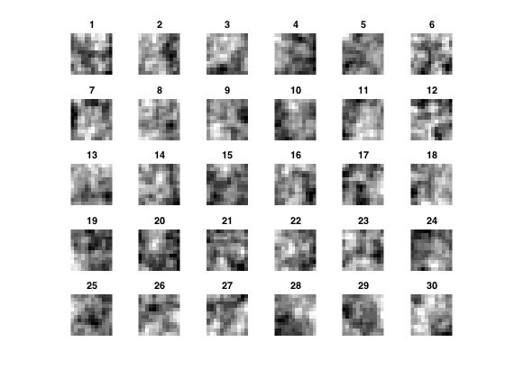

Figure , Display Column A, mixing matrix

From figure 3, I can tell that each of the frames represents one commen element (feature) of the image batch.

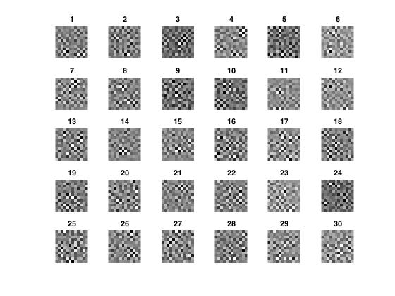

Figure : Display Column W, learned weights